**Web Server Configuration in CentOS:**

Mounting the drive:

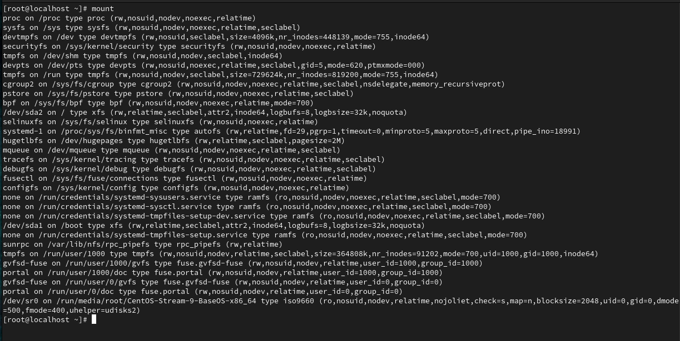



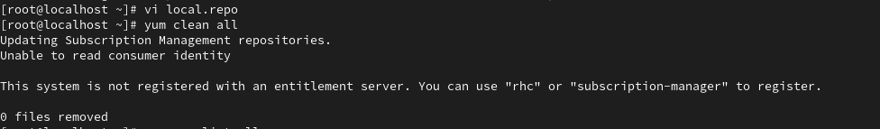

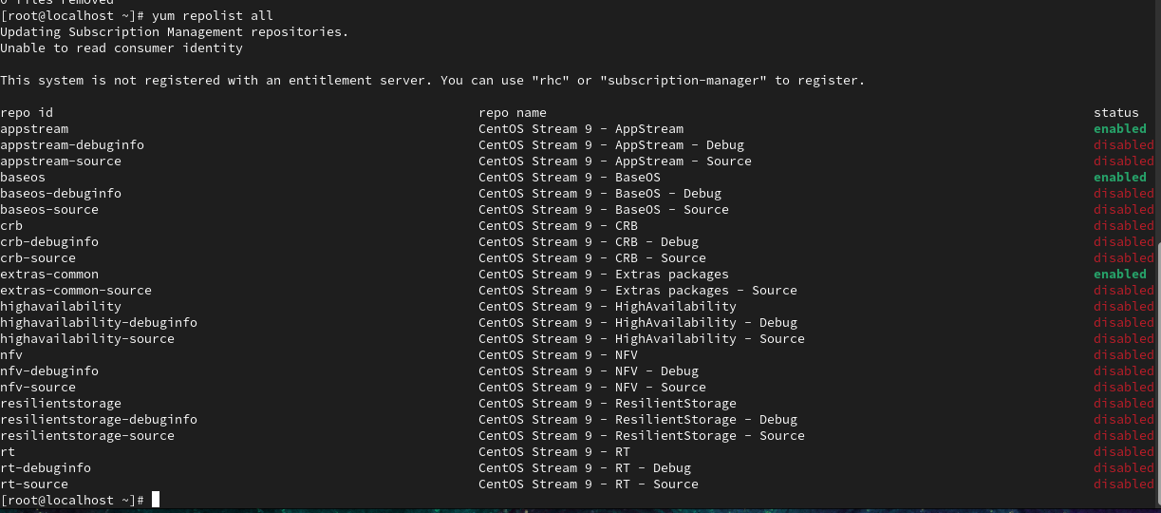

**Start and Enable the Web Server:**

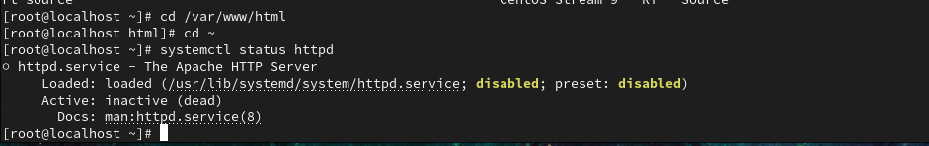

**Configuring the Firewall:**

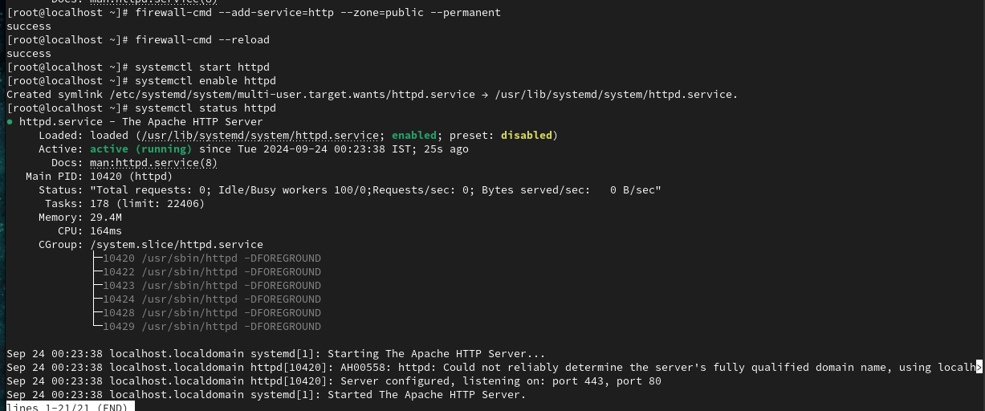

**Configuring IP Address:**

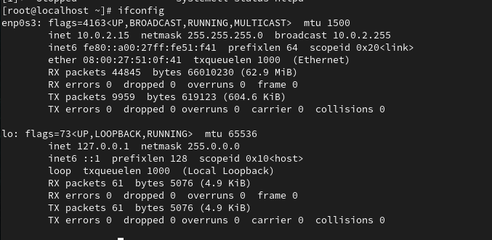

**Open a web browser and enter the server's IP. It'll show the test page.**

